**DAR ES SALAAM INSTITUTE OF TECHNOLOGY (DIT)**



DEPARTMENT OF COMPUTER STUDIES

FUNDAMENTALS OF DATA STRUCTURES AND ALGORITHMS

(ITT 05213)

TUTOR: Mr. YUSTIN MWINUKA

CLASS: OD22IT SEMESTER II

GROUP ASSIGNMENT

|  |  |  |
| --- | --- | --- |
| **S/N** | **GROUP MEMBER** | **REGISTRATION NO** |
| 1 | BENARD PAUL MANYANDA | 220229476505 |
| 2 | PRINCE NESTORY KYANDO | 220627357067 |
| 3 | MARTIN SHIJA BULOLO | 220229337481 |

Question: Discuss intensively the tree and graph data structures.

1. **Tree Data Structures:**

This is a non-linear data structure that is used to organize data with hierarchical relationships in a logical and efficient manner. Trees have a root node, branches, and leaf nodes. The root node is the topmost node, and each child node is linked to a parent node. The leaf node is the node that does not have any child nodes. There are different types of trees, including binary, AVL, and B-trees.

Binary trees are trees that have at most two child nodes. AVL trees are self-balancing binary search trees that ensure that the difference between the height of the left and right subtrees of each node is not greater than one. B-trees are multi-node search trees that store data in an ordered manner and are commonly used in database systems.

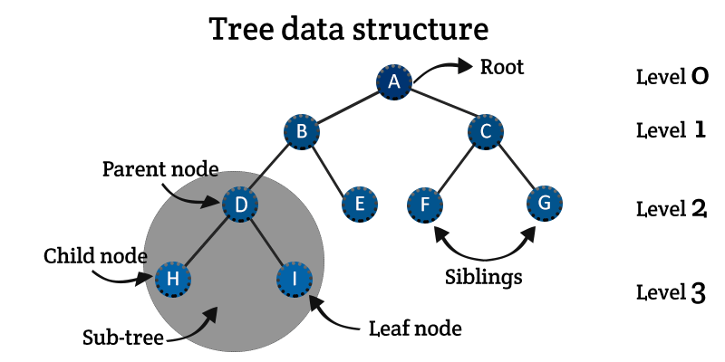

1. **Graph Data Structures:**

This is a data structure that is used to represent the interconnectedness between elements. A graph consists of a set of nodes and a set of edges that connect them. Nodes are the vertices of the graph, while edges are the links between nodes.

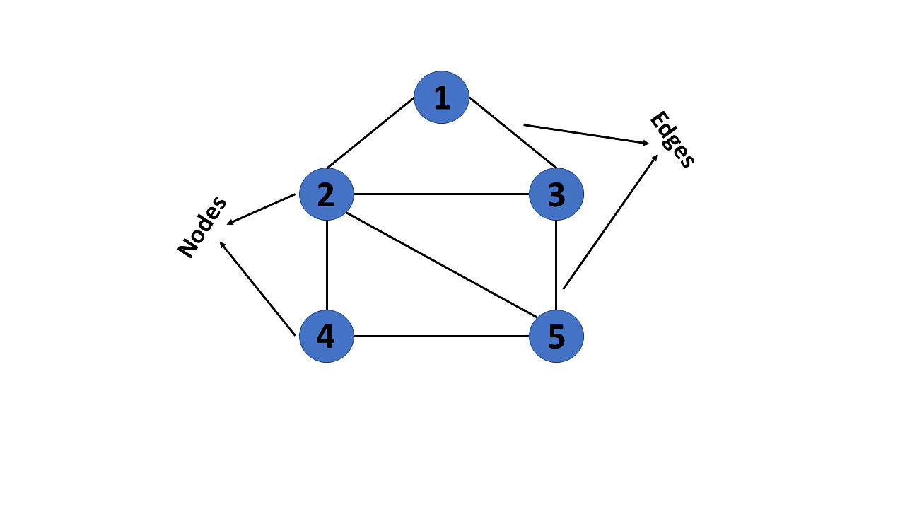

Graphs can be directed or undirected, weighted or unweighted, and acyclic or cyclic. In a directed graph, the edges have a direction, while in an undirected graph, they don't. In a weighted graph, edges have weights or costs associated with them. In an unweighted graph, all edges have the same weight. In an acyclic graph, there are no cycles, while in cyclic graphs, there are cycles.

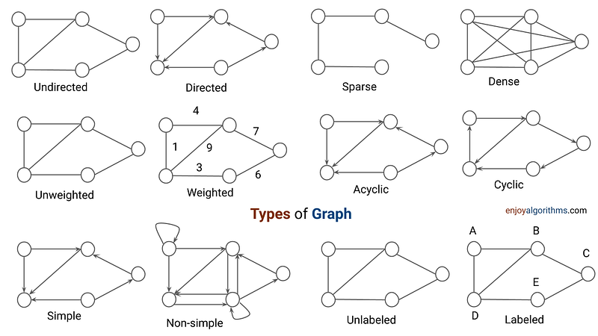

**APPLICATIONS OF TREE AND GRAPH DATA STRUCTURES:**

Tree and graph data structures have numerous applications in computer science. Trees are used for storing and accessing data in hierarchical formats, such as file systems. Graphs are used for modeling relationships in different fields, such as social networks, transportation systems, and computer networks.

**Example applications of tree and graph data structures include:**

1. File systems and directory structures: Trees are used to store data in the file systems by organizing files and directories in a hierarchical structure.
2. Computer network protocols: Graphs are used to model the protocols used in computer networks, such as IP.
3. Artificial intelligence and machine learning: Graphs are used to model decision-making systems in artificial intelligence and machine learning applications.
4. Geographical Information Systems (GIS) and mapping: Trees and graphs are used to model spatial relationships and map information in GIS applications.